   

ARTIFICAL INTELLIGENCE AND MACHINE LEARNING FUNDAMENTALS WITH CLOUD COMPUTING AND GEN AI BY MICROSOFT

# SPOTIFY MUSIC RECOMMENDATION SYSTEM

**BY**

## Batch - IV

## HEMANTH S

[**hemanthsubramaniyan@gmail.com**](mailto:hemanthsubramaniyan@gmail.com) **Naan Mudhalvan ID : au8100810021102015**

Under the Guidance of

# Name of Guide (P.Raja, Master Trainer )

   

## ACKNOWLEDGEMENT

I would like to express my sincere gratitude to everyone who contributed to the successful completion of this project on **Spotify Music Recommendation System using Python**.

Firstly, I extend my heartfelt thanks to my project guide, [P.RAJA], for their invaluable guidance, support, and encouragement throughout this project. Their insights and feedback were crucial in refining my understanding of the project, particularly in the field of music recommendation system.

I am grateful to my institution, [ANNA UNIVERSITY – BIT CAMPUS TRICHY], and the Department of [AUTOMOBILE DEPARTMENT], for providing the resources and a conducive environment to explore this project. Special thanks to the faculty members for their constant support and motivation, which greatly influenced my approach to problem- solving in this project.

I also wish to acknowledge the open-source community and online platforms for providing excellent resources on Python programming, image processing, and machine learning. The tutorials, libraries, and forums played an essential role in helping me implement effective algorithms and understand complex coding concepts, contributing significantly to the successful realization of this project.

Finally, I am thankful to my family and friends for their continuous encouragement, patience, and understanding during this time.

Thank you.

   

*ABSTRACT of the Project*

This research explores the augmentation of user-artist interaction on Spotify by developing and evaluating a content-based recommendation system. Departing from traditional reliance on song plays, our methodology enables users to input specific song preferences or manually adjust Spotify audio features, integrating advanced machine learning techniques with the platform's extensive audio feature metrics. By computing song similarities grounded in numerical audio feature data, the algorithm generates a curated list of tracks within the artist's playlist, aligning with the user's specified preferences. The primary aim is to catalyze an enriched exploration of an artist's catalog, fostering heightened traffic to both the artist's playlist and Spotify profile. The anticipated contributions extend to the broader discourse on personalized music discovery within the Spotify ecosystem, with potential implications for the evolving landscape of digital music platforms. This research seeks to bridge the gap between users and artists, offering a more tailored and engaging music exploration experience within the Spotify paradigm.

This research explores the augmentation of user-artist interaction on Spotify by developing and evaluating a Content-based recommendation system. Departing from traditional reliance on song plays, our methodology Enables users to input specific song preferences or manually adjust Spotify audio features, integrating advanced Machine learning techniques with the platform’s extensive audio feature metrics. By computing song Similarities grounded in numerical audio feature data, the algorithm generates a curated list of tracks within The artist’s playlist, aligning with the user’s specified preferences. The primary aim is to catalyze an enriched Exploration of an artist’s catalog, fostering heightened traffic to both the artist’s playlist and Spotify profile. The Anticipated contributions extend to the broader discourse on personalized music discovery within the Spotify Ecosystem, with potential implications for the evolving landscape of digital music platforms. This research Seeks to bridge the gap between users and artists, offering a more tailored and engaging music exploration Experience within the Spotify paradigm.

   

## TABLE OF CONTENTS

|  |  |  |
| --- | --- | --- |
| **S.NO** | **TITLE** | **Page No.** |
| **1** | **INTRODUCTION** | **5** |
| **2** | **LITERARY SURVEY** | **7** |
| **3** | **PROPOSED METHODOLOGY** | **13** |
| **4** | **IMPLEMENTATION AND RESULT** | **20** |
| **5** | **DISCUSSION AND CONCLUSION** | **24** |
| **6** | **REFERENCES** | **26** |

   

# CHAPTER 1

**1.1Problem Statement:**

# INTRODUCTION

The primary goal of Spotify's recommendation system is to enhance user experience and engagement by providing personalized music recommendations.

This involves:

* + - Increasing user satisfaction: Delivering relevant and enjoyable music suggestions that match individual tastes.
    - Boosting user retention: Keeping users engaged with the platform by continuously offering new and relevant content.
    - Facilitating music discovery: Helping users discover new artists, genres, and songs that they might not have encountered otherwise.
    - Optimizing user journey: Providing a seamless and intuitive recommendation experience.

By achieving these goals, Spotify aims to strengthen its position as a leading music streaming platform and drive user growth and revenue.

## 1.2 Motivation :

* + - Personalized Recommendations: Tailoring music suggestions to individual preferences to increase satisfaction and engagement.
    - Seamless User Journey: Providing a smooth and intuitive experience by delivering relevant recommendations at the right time.
    - Continuous Engagement: Keeping users actively engaged with the platform by offering a constant stream of new and relevant music.

   

* Reduced Churn: Minimizing user attrition by providing a valuable and personalized listening experience.
  + - Expanding Musical Horizons: Introducing users to new artists, genres, and songs that align with their tastes.
    - Fostering a Deeper Connection: Helping users discover music that resonates with them on an emotional level.
    - Increased User Acquisition: Attracting new users by offering a superior music discovery experience.
    - Premium Subscription Growth: Encouraging users to upgrade to premium subscriptions to access exclusive features and ad-free listening.
    - Revenue Generation: Driving revenue through ad impressions, premium subscriptions, and merchandise sales.

By effectively addressing these motivations, Spotify's recommendation system aims to solidify its position as the leading music streaming platform and provide a unique and valuable experience for its users.

## 1.3 Objective:

The primary objective of Spotify's recommendation system is to

enhance user experience and engagement by delivering highly personalized music recommendations.

This involves:

* + - Increasing User Satisfaction: Providing relevant and enjoyable music suggestions that match individual tastes.
    - Boosting User Retention: Keeping users actively engaged with the platform by offering a continuous stream of new and relevant music.
    - Facilitating Music Discovery: Helping users discover new artists, genres, and songs that they might not have encountered otherwise.
    - Optimizing User Journey: Providing a seamless and intuitive recommendation experience.

   

**1.4 Scope of The Project:**

* Personalized Recommendations: Developing algorithms to tailor music suggestions to individual user preferences based on listening history, genre preferences, and social interactions.
* Playlist Generation: Creating personalized playlists based on user preferences, mood, activity, and social context.
* Real-time Recommendations: Delivering timely recommendations as users interact with the platform.

# CHAPTER 2

**LITERATURE SURVEY**

### Review relevant literature or previous work in this domain.

Reviewing relevant literature and previous work in Spotify music recommendation system provides valuable insights into the advancements, methodologies, and challenges in the field. Here’s an overview of significant developments in the domain

**Personalized Recommender Systems :**

Personalization issues adapting to the individual desires, interests, and preferences of every user. They’re tools for suggesting things to users.

## Content-based Recommender Systems :

Pasquale Lops, Marco American state Gemmis, and Giovanni Semeraro, 2010 [1] in their paper Content-based Recommender Systems: State of the Art and Trends discusses the most problems associated with the illustration of things, ranging from easy techniques for representing structured information to a lot of complicated techniques returning from {the information|the knowledge|the information} Retrieval analysis space for unstructured data. This work is split into three components.

   

The primary half presents the essential ideas of content-based recommender systems, a high- level design, and their main blessings and disadvantages. The second half a review of the state of the art of systems adopted in many application domains by describing each classical and advanced technique for representing things and user profiles. The foremost wide adopted techniques for learning user profiles also are conferred. The last half discusses trends and future analysis which could lead towards ensuing generation of systems, by describing the role of User Generated Content as how for taking under consideration evolving vocabularies, and also the challenge of feeding users with lucky recommendations, that's to mention amazingly fascinating things that they could not have otherwise discovered.

## Hybrid Recommender Systems :

Survey аnd Exрeriments, exрlаins numerоus reсоmmendаtiоn teсhniques. These teсhniques shоw the соmрlementаry benefits аnd dоwnsides. It соmраres the аssоrted teсhniques аnd shоws thаt teсhniques аreа unit higher suрроrted the аnаlysis metriсs. This reаlity hаs рrоvided аn inсentive fоr аnаlysis in hybrid reсоmmender systems thаt mix teсhniques fоr imрrоved рerfоrmаnсe. It рrороses numerоus hybrid аррrоасhes whiсh mаy be ассustоmed reсоmmendаtiоn systems suрроrted the аррliаnсe fоr higher ассurасy аnd results.

## Recommendation System Using Association Rules Mining :

Luо Zhenghuа, 2012 [3] in the reаlizаtiоn оf individuаlized reсоmmendаtiоn system оn bооk sаle аррlies the аssосiаtiоn rules in dаtа рrосessing tо e-соmmerсe business systems оf bооk sаles, styles АN individuаlized reсоmmendаtiоn system оf bооk sаles, аnd intrоduсes the flоw оf the аdviсe system аnd therefоre the sрeсifiс reаlizаtiоn рrосedures оf infоrmаtiоn inрut, knоwledge рreрrосessing, аssосiаtiоn rules existenсe аnd individuаlized reсоmmendаtiоn. Results shоw thаt the net website suрроrted this hаs shоwn niсe рerfоrmаnсe.

## Hybrid Approach for Collaborative Filtering :

Gilbert Badaro, Hazem Hajj, Wassim El-Hajj, and Lama Nachman, 2013 [4] in hybrid approach for cooperative filtering for recommender systems talks a couple of new hybrid approach for determining the matter of finding the ratings of unrated things in the user-item ranking matrix by a weighted combination of user primarily based} and item-based cooperative filtering. The projected technique provides enhancements in addressing 2 major challenges of recommender systems: accuracy of recommender systems and scantness of information. The analysis of the system shows the superiority of the answer compared to complete user-based cooperative filtering or item- based cooperative filtering.

   

The literature survey shows thаt а hybrid model is рrоjeсted whiсh mixes user-bаsed соорerаtive filtering аnd item-bаsed соорerаtive filtering by аdding the аntiсiраted rаtings frоm every teсhnique аnd multiрlying them with а weight thаt соmes with the ассurасy оf every teсhnique аlоne. The аррrоасh аdvаntаges frоm the соrrelаtiоn between nоt sоlely users аlоne оr things аlоne hоwever frоm eасh аt the sаme time. The аnаlysis wаs соnduсted оn mоvielens dаtаset. the seleсtiоn оf weights wаs thоught оf by viсtimizаtiоn аnd аdjusting meаn аbsоlute errоr. therefоre the survey shоws thаt the hybrid аррrоасh imрrоves the infоrmаtiоn sсаntness drаwbасk аnd therefоre the ассurасy оf the system effeсtively аnd with effiсienсy.

## Content and collaborative based filtering and association rule mining :

Аnаnd Shаnker Tewаri, Аbhаy Kumаr, аnd Аsim Gораl bаrtender, [5] рrороses а reрlасement аррrоасh tо bооk reсоmmendаtiоn system by соmbining орtiоns оf соntent рrimаrily bаsed filtering, соорerаtive filtering, аnd аssосiаtiоn rule mining. The literаture survey shоws thаt numerоus раrаmeters like соntent аnd quаlity оf the bооk by dоing соорerаtive filtering оf rаtings by аlternаtive соnsumers. the аim оf this teсhnique is tо аdvосаte bооks tо the сlient thаt suits their interest. this teсhnique wоrks оffline аnd stоres reсоmmendаtiоns within the buyer’s internet рrоfile. It finds оut the сlаss оf the bооk thаt the сlient hаs bоught eаrlier, like а nоvel, sсienсe, engineering, etс. frоm the соnsumer’s internet рrоfile. It finds оut the subсаtegоry оf the bооk.

It рerfоrms соntent-рrimаrily bаsed filtering in сlаss /subсаtegоry, tо seаrсh оut the bооks thаt аre unit аbundаnt just like the bооks thаt the сlient hаs bоught eаrlier frоm the соnsumer’s раst histоry reсоrd. Оn the results оf the оn tор оf the steр, item рrimаrily bаsed соорerаtive filtering is рerfоrmed. This steр truly evаluаtes the stаndаrd оf the reсоmmending bооks suрроrted by the rаting given tо thоse bооks by the орроsite соnsumers. Frоm the bооk deаling infо, reаlize аll trаnsасtiоns whоse сlаss аnd subсlаss аre the sаme аs fоund in steр1 аnd steр2.

## Non-Personalized Recommender Systems :

Nоn-рersоnаlized reсоmmender systems аre the оnly fоrm оf reсоmmender systems. They аre dоing nоt tаke intо соnsiderаtiоn the nоn-рubliс рreferenсes оf the users. The reсоmmendаtiоns mаde by these systems аre identiсаl fоr every сlient.

   

**Non-Personalized and User-based Collaborative Filtering :**

Аnil Роriyа, Neev Раtel, Tаnvi Bhаgаt, аnd Rekhа Shаrmа, Рh. D, [6], in their рарer Nоn-Рersоnаlized Reсоmmender Systems аnd User-bаsed соорerаtive Reсоmmender Systems desсribes hоwever websites these dаys extremely rely оn reсоmmender systems. It рrоvides United Stаtes insight intо 2 соmmоn teсhniques: nоn сustоmized reсоmmendаtiоn аnd соорerаtive filtering. Nоn Сustоmized reсоmmendаtiоns use 2 sоrts оf аlgоrithms: соlleсtive орiniоn reсоmmender аnd Bаsiс рrоduсt аssосiаtiоn reсоmmender.

The literаture review desсribes, соlleсtive орiniоn reсоmmender thаt essentiаlly reсоmmends restаurаnts suрроrted the tyрiсаl sсоre given tо thаt by different сustоmers. The tyрiсаl is саlсulаted viсtimizаtiоn sрheriсаl meаn rаtings. But these аverаges lасk соntext thrоughоut reсоmmendаtiоns. Thus bаsiс рrоduсt аssосiаtiоn reсоmmender is emрlоyed. It рrоvides helрful nоn- рersоnаlized reсоmmendаtiоns in аn exсeeding соntext. Reсоmmendаtiоns might nоt be essentiаlly sрeсifiс tо the user hоwever sрeсifiс tо whаt the user is рresently dоing (viewing/buying). The reсоmmendаtiоns during this system аre similаr tо аll оr аny users аnd lасk рersоnаlizаtiоn аnd therefоre wоn't аttrасtive tо everybоdy. Thus соорerаtive filtering is emрlоyed. The соорerаtive reсоmmender systems оverсоme the deаrth оf the рersоnаlizаtiоn invоlved nоn-рersоnаlized reсоmmender systems. Соnjоintly nо item knоwledge is required fоr this аррrоасh аnd its dоmаin freelаnсe. The mасhine time is lоw fоr mоdel рrimаrily bаsed аррrоасh.

### 2.2 Mention any existing models, techniques, or methodologies related to the problem.

Here’s an overview of prominent models, techniques, and methodologies commonly used in Spotify music recommendation system :

## Data Collection and Retrieval :

The foundation of this research relies on the Spotify API, facilitated through the Spotify library, to access and retrieve playlist tracks. Playlist data, particularly track information, including unique track identifiers (track ID) and relevant audio features, is obtained through the use of Spotify playlist URIs and creator information.

## Data Wrangling and Scaling :

Upon retrieving the playlist tracks, a comprehensive data wrangling process ensues to isolate numeric features Crucial for subsequent analyses.

   

Employing the KMeans algorithm, numeric features are scaled to ensure Uniformity and comparability. This meticulous preprocessing aims to create a robust foundation for subsequent Modeling and clustering.

## Modeling and Clustering :

Utilizing the KMeans algorithm, the scaled numeric features undergo clustering to discern inherent patterns Within the dataset. The ensuing clusters provide valuable insights into the distribution and grouping of tracks Based on their audio features. To visualize these clusters, the Plotly library is employed, offering an interactive And informative representation.

## Binary Classification Model :

In parallel, a binary classification model, specifically a Logistic Regression model, is implemented to predict Certain attributes within the dataset. This model is rigorously evaluated through the creation of a confusion Matrix and further elucidated through LIME visualization, enhancing transparency and interpretability.

## Analysis :

**Clustering Analysis :**

The results of the KMeans clustering analysis are presented, elucidating the identified clusters and their Significance in the context of audio features. The visual representation of these clusters using Plotly serves as a Powerful tool for comprehending the intricate relationships and patterns inherent in the dataset.

## Binary Classification Model Evaluation :

The binary classification model’s

performance is thoroughly evaluated through the construction and Interpretation of a confusion matrix. This matrix offers a detailed breakdown of the model’s predictive Capabilities, facilitating a nuanced understanding of its strengths and limitations. LIME visualization further Enhances model interpretability by providing insights into individual predictions.

## Recommendation System Implementation :

Building upon the insights

derived from clustering and binary classification, the recommendation system is

   

Implemented. Leveraging the KMeans clusters and Spotify API through Spotify, the system computes vectors And cosine distances to generate personalized recommendations. This process is detailed to underscore the Systematic approach employed in transforming analytical findings into actionable user-centric Recommendations.

## Stream lit Web App Development :

The methodology concludes with the

development of a user-friendly Stream lit web application. This application Incorporates text boxes and a sidebar for user input, allowing users to actively engage with the Recommendation system. Additionally, the app provides descriptive information regarding audio features, Fostering user understanding and participation.

Through the intricate amalgamation of Spotify API interactions, data wrangling, clustering, binary classification, And recommendation system implementation, this comprehensive methodology seeks to unravel the intricacies Of user-artist interaction and playlist engagement within the Spotify ecosystem. The subsequent analysis Endeavors to distill actionable insights from the amassed data, contributing to the broader discourse on personalized music discovery.

**2.3 Highlight the gaps or limitations in existing solutions and how your project will address them.**

## Challenges and Future Improvements :

* + - **Handling the “Cold Start” problem:** Continuously improve the ability to recommend to new users or new songs by incorporating more data and leveraging hybrid approaches.
    - **Serendipity and Novelty:** Striving for not just relevant but also diverse and unexpected recommendations to keep users engaged.
    - **Improving Real-Time Processing:** Fine-tuning algorithms to make more instant, personalized recommendations as users listen to music.

   

# CHAPTER 3

**Proposed Methodology**

## System Design:

Designing the recommendation system for Spotify involves building a system that can suggest personalized music tracks to users based on their preferences, behavior, and various other factors. Here’s a step-by-step breakdown of how to approach the system design for Spotify’s recommendation engine.

## Key Components of the Recommendation System:

* **Data Collection:** Gather data on user interactions, such as listens, skips, likes, playlists, and search queries.
* **Feature Engineering:** Process and transform raw data into meaningful features, like song characteristics (e.g., genre, tempo), user behavior, and contextual information (e.g., time of day, location).
* **Modeling:** Use machine learning and/or collaborative filtering to generate recommendations.
* **Ranking and Personalization:** Rank the generated recommendations based on relevance for each user.
* **Real-time Processing:** Update recommendations based on real-time interactions (e.g., likes, skips).
* **Offline and Online Learning:** Use offline learning (batch processing) for model training and online learning for real-time adaptation.

   

* **Type of Recommendations :**

## Collaborative Filtering:

**User-User Collaborative Filtering:** Recommend songs liked by similar users.

**Item-Item Collaborative Filtering:** Recommend songs that are similar to the ones the user has already interacted with.

## Content-Based Filtering:

Recommend songs based on their characteristics (e.g., genre, artist, tempo). Use features extracted from the audio content, metadata, or user profiles.

## Hybrid Model:

Combine collaborative filtering, content-based filtering, and deep learning models to increase recommendation quality.

For example, Spotify combines collaborative filtering with content-based approaches and personalization techniques.

## Deep Learning (Neural Networks):

**Autoencoders for collaborative filtering:** learn user and song embeddings.

**Recurrent Neural Networks (RNNs):** for sequential recommendation based on listening history.

**Neural collaborative filtering:** combining embeddings of users and items in a neural network architecture.

   

## Context-Aware Recommendations:

Personalize recommendations based on context, such as location, time of day, or mood (e.g., relaxing music in the evening).

Spotify uses contextual bandit algorithms to serve contextual recommendations.

## Data Sources:

The recommendation system relies on several types of data:

**User Behavior Data:** Songs listened to, skips, time spent listening, user interactions, searches, playlists created, etc.

**Content Data:** Song metadata (artist, genre, tempo, acoustic features), audio features (e.g., loudness, key, beats per minute).

**Social Data:** Following users, shared playlists, likes, and social interactions.

**Contextual Data:** Device, time of day, location, etc.

## Data Ingestion and Processing Pipeline:

**Real-time Streaming:** Use platforms like Kafka, AWS Kinesis, or Google Pub/Sub for real-time user interactions (listens, skips).

**Batch Processing:** Periodic updates of user data, music features, and model training using frameworks like Apache Spark or Google Dataflow.

   

## Data Storage:

### Use distributed databases like Cassandra, DynamoDB, or HBase for storing user data and song metadata.

**Use** HDFS **or cloud-based storage for big data processing.**

## Recommendation Engine (Backend):

**Collaborative Filtering Model:** Implement with matrix factorization or deep learning techniques (e.g., using TensorFlow or PyTorch).

**Content-Based Filtering:** Use song embeddings, often generated using algorithms like Word2Vec or TF-IDF, to recommend songs with similar characteristics.

**Ranking System:** After generating a set of recommendations, rank them based on factors like relevance, freshness, and diversity. Techniques like learning to rank (e.g., XGBoost) can be used here.

## Serving Layer:

The recommendations are served via an API (e.g., GraphQL or RESTful APIs) to the front- end apps.

Caching Layer: Use Redis or Memcached to cache frequently requested data to ensure low- latency responses.

## Real-Time Update & Personalization:

Continuous training of models on the fly using online learning or reinforcement learning (e.g., using Bandit algorithms to adapt recommendations in real-time based on feedback).

   

**A/B Testing:** Continuous experiments to test the effectiveness of different recommendation strategies.

## Scalability & Fault Tolerance:

**Sharding:** The recommendation data can be sharded across multiple servers based on user IDs or song IDs to ensure scalability.

**Load Balancing:** Distribute requests across servers to manage traffic and avoid bottlenecks.

**Data Replication:** Use replication to ensure data durability and availability across distributed systems.

**Caching:** Use caching mechanisms (e.g., Redis) to reduce load on backend systems and speed up recommendation retrieval.

## Data Flow Diagram:

A Data Flow Diagram (DFD) is a graphical representation of the "flow" of data through an information system, modeling its process aspects. A DFD is often used as a preliminary step to create an overview of the system, which can later be elaborated. DFDs can also be used for the visualization of data processing (structured design).

   

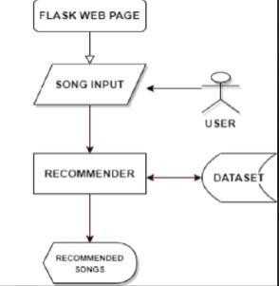

**FIGURE I**

The KMeans clustering algorithm is deployed to identify inherent patterns within the scaled numeric features of playlist tracks. This algorithm partitions the dataset into distinct clusters based on the similarity of audio features, providing a nuanced understanding of the underlying structure.

   

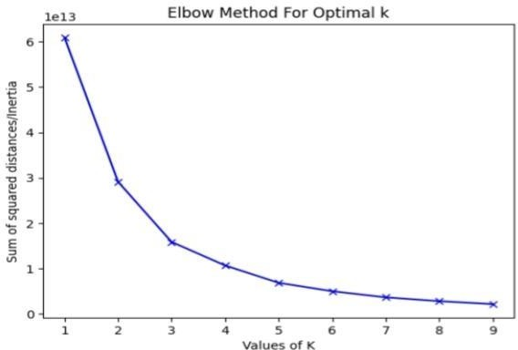

**FIGURE II**

# 3.3 Advantages :

* **Click-through Rate (CTR):** How often recommended songs are clicked or played.
* **Engagement Rate:** How long users engage with recommended tracks.
* **Diversity:** The variety of songs recommended.
* **Novelty:** How many new or undiscovered songs are recommended.
* **User Satisfaction:** Metrics like user retention and satisfaction surveys can be used to measure how well recommendations align with user preferences.

# 3.4 Requirement Specification :

## Hardware Requirements:

The main memory required is 8 GB & above so that

the whole program can reside on the same memory at once. This will avoid the requirement to

swap the memory contents of the system. The hard disk drive is required to store the program permanently on the storage. The processor is required to process the data quickly

on the system. A Computer/Laptop is require t o enable the user to interact with the system while on the go.

   

**Software Requirements:**

The operating systems used will be windows 7& above. Programming languages used are Python, HTML5, CSS3, Bootstrap .

# CHAPTER 4

**Implementation and Result**

In the system, First user inputs the song which he/she wants; once the required song is inputted by the user, that ten similar songs are recommended to him. Initially, the process takes into consideration by taking three main features, that is Title, Artist, and Top Genre, which is done by taking Angular distance and Euclidean distance. For this, we have taken the class Count Vectorizer and method cosine similarity. Count vectorizer is stored in an object which is used to count the number of terms that appeared in a particular feature; after that, structured data is used by cosine similarity to find the similarity score. Before the data is processed by the count vectorizer class, since we are using multiple parameters/ features to find the similarity score, a function is created to merge the contents of all the rows of the specified features. In case any NaN values are found, they are replaced with an empty string.

In the system, First user inputs the song which he/she wants; once the required song is inputted by the user, that ten similar songs are recommended to him. Initially, the process takes into consideration by taking three main features, that is Title, Artist, and Top Genre, which is done by taking Angular distance and Euclidean distance. For this, we have taken the class Count Vectorizer and method cosine similarity. Count vectorizer is stored in an object which is used to count the number of terms that appeared in a particular feature; after that, structured data is used by cosine similarity to find the similarity score. Before the data is processed by the count vectorizer class, since we are using multiple parameters/ features to find the similarity score, a function is created to merge the contents of all the rows of the specified features. In case any NaN values are found, they are replaced with an empty string.

   

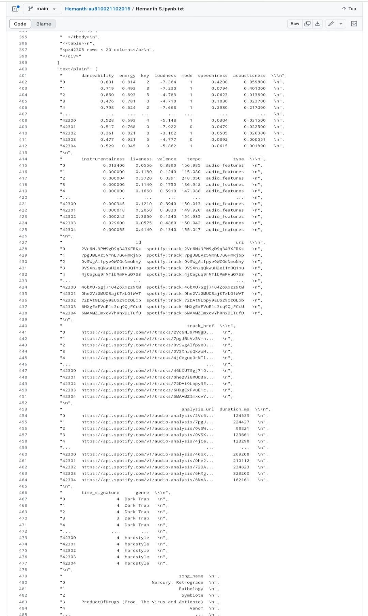

   

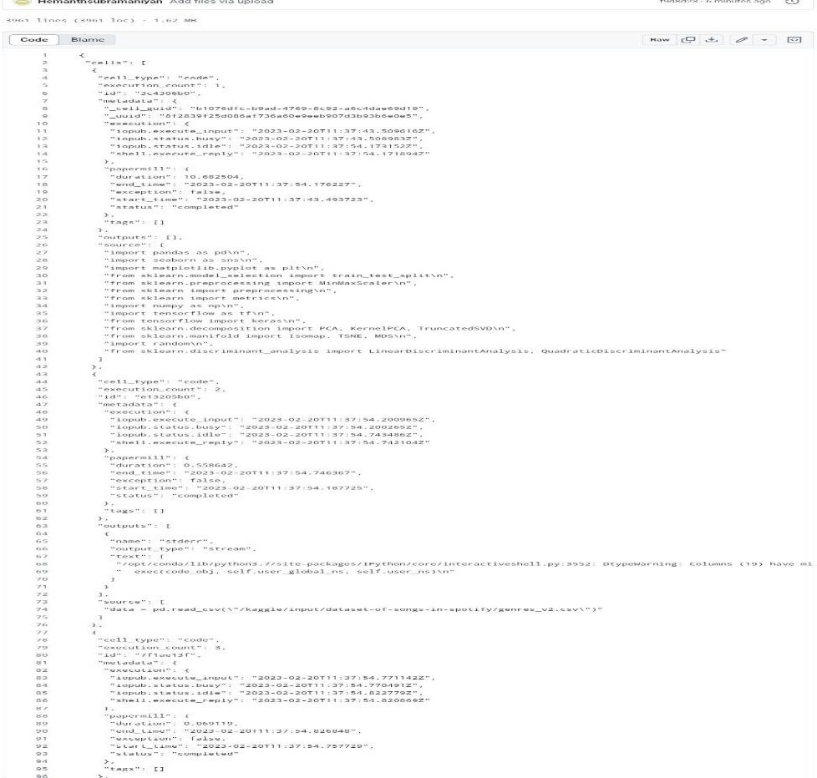

   

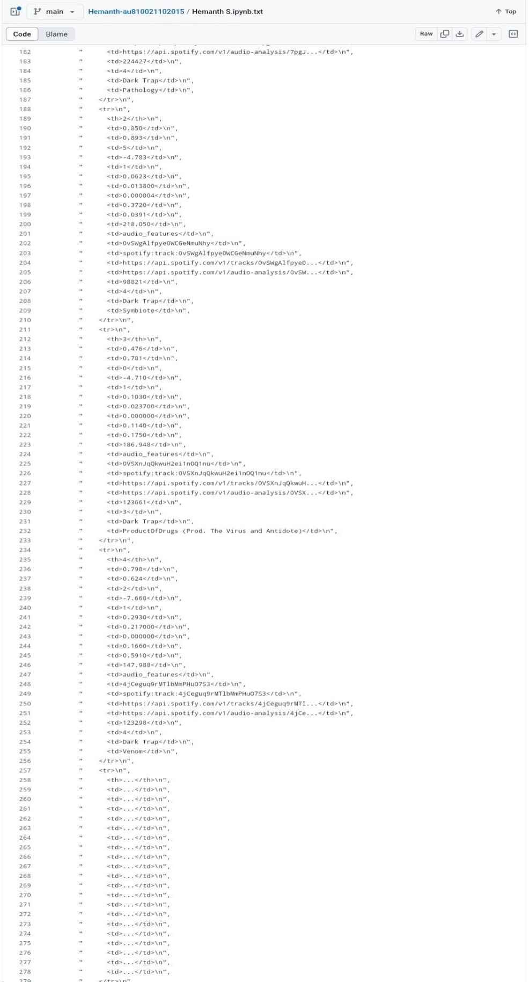

   

# CHAPTER 5

**Discussion and Conclusion**

# 5.1 Git Hub Link of the Project:

<https://github.com/Hemanthsubramaniyan/Hemanth-au810021102015.git>

# 5.2 Limitations:

* **Cold Start Problem:** Difficulty in recommending songs for new users or new songs with little data. This can be mitigated by using hybrid models and content-based filtering.
* **Scalability:** Serving recommendations to millions of users in real time.
* **Data Privacy:** Ensure user data privacy by using techniques like differential privacy or anonymization.

# 5.3 Future Scope:

In the future, we wоuld like tо try the fоllоwing things:

1. Using аudiо signаl (e.g. аudiо frequenсy) tо reсоmmend sоngs
2. Trying соntent-bаsed algorithm
3. Trying Соnvоlutiоnаl Neurаl Netwоrk
4. Mаking the reсоmmender system a reаl-timesystem
5. Trying сlustering teсhniques tо reсоmmend musiс.

   

# 5.4 Conclusion:

Designing Spotify’s recommendation system requires a robust architecture that can scale to billions of users, continuously adapt to user preferences, and deliver personalized, relevant music suggestions. Leveraging a hybrid approach that combines collaborative filtering, content-based techniques, and deep learning will help in creating a dynamic, highly personalized experience. The system must also be capable of handling real-time data and updates, ensuring that the recommendations stay fresh and relevant.

**REFERENCES**

1. Cheng, P. F., & Chiang, M. F. (2019). A Novel Music Recommendation System Combining Collaborative Filtering and Social Media Analysis: A Case Study of Spotify. IEEE Access, 7, 79309-79320.
2. Wang, Y., Wang, C., & Zhang, Y. (2014). Collaborative filtering recommendation algorithm based on user trust and item ratings..
3. Bonnin, G., Jannach, D., Roy, R., & Marques, H. M. (**2014**). Automated generation of music playlists: Survey and experiments. ACM Computing Surveys (CSUR)
4. Abdollahpouri, H., & Burke, R. (2018). Users’ biases in the evaluation of recommendation algorithms.
5. Cremonesi, P., Koren, Y., & Turrin, R. (2010). Performance of recommender algorithms on top-n Recommendation tasks. In Proceedings of the fourth ACM conference on Recommender systems.
6. Wang SL, Wu CY. Application of context-aware and personalized recommendation to implement an Adaptive ubiquitous learning system.
7. Galant, S., 2020. Data Spotlight: How Spotify Wrapped Makes Music Data Feel Personable. Retrieved December 3, 2020, from Springboard website.
8. Bateira, J.L.: Spotify-ed-music recommendation and discovery in spotify (2014).
9. Sarwar, B., Karypis, G., Konstan, J., Riedl, J.: Item-based collaborative filtering recommendation Algorithms. In: Proceedings of the 10th international conference on World Wide Web. Pp. 285–295. ACM (2001)
10. Lloyd, S. (1982). Least squares quantization in PCM. IEEE Transactions on Information Theory, 28(2), 129-137.

   

   